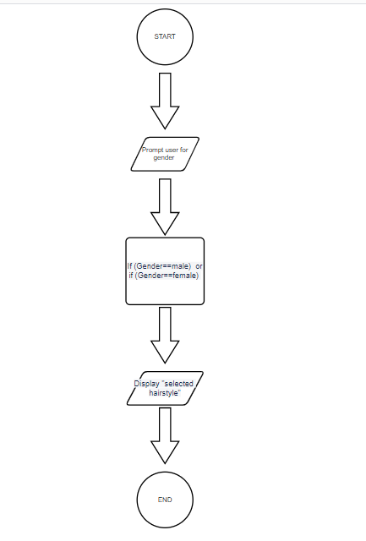

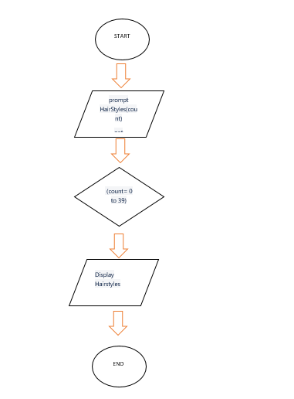

END

Display Hairstyles

 (count= 0 to 79)

prompt HairStyles(count)

get HairStyles(count)

START